Sheridan WYO Rodeo Royalty Contest
Sr. Princess Pattern
Ages 16-18 yrs old
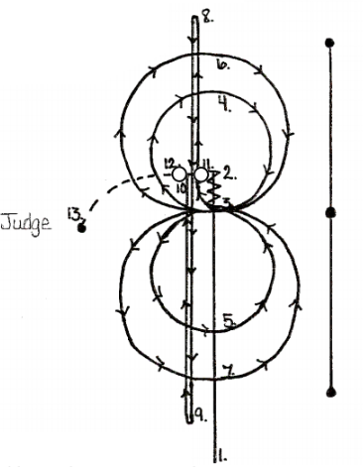

1. to 2. Run with speed past center marker.
2. Stop and back up to center of pattern.
3. Settle here for approximately 10 seconds. Start lope to the right. Figure eight should be inside end markers.
4. And 5. Ride small figure eight at moderate lope.
6. And 7. Ride larger figure eight at a faster lope, continue lope past point
8. Change leads and run past end marker and turn to the left
9. Run to far end past end marker and turn to the right
10. Run to center of pattern, stop and settle horse for approximately 10 seconds.
11. Do a right or left pivot (180 degrees)
12. Pivot opposite direction (180 degrees)
13. Walk to judge and stop. Dismount.
14. Judges will ask questions for horsemanship interview.

