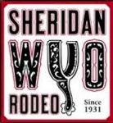Sheridan WYO Rodeo Queen Contract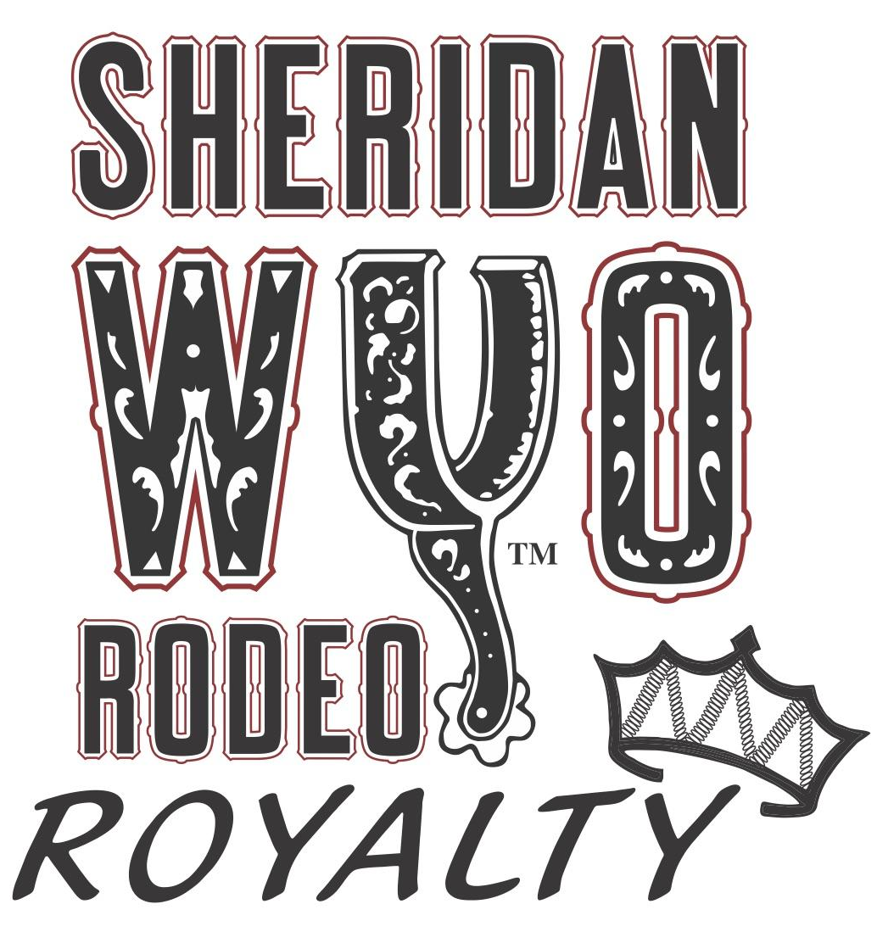

I, _________________________________________, having entered and participated in the Sheridan WYO Rodeo Queen Contest with the understanding and knowledge of the terms and conditions of this Contract and understanding that if designated “Sheridan WYO Rodeo Queen” I would be required to enter into this Contract as a condition of being to designated, make the following statements and representations to, and agreements with Sheridan WYO Rodeo Queen Contest, and the Sheridan WYO Rodeo Queen Board (SWRQB); and being first duly sworn upon oath, do depose and say:

1. I am a natural born female citizen of the United States of America and reside

in__________________________, County of_______________, State of Wyoming.

2. I meet the resident requirements put forth by the SWRQB.

3. I have reached my nineteenth birthday by date of competition and will not have reached my twenty-fifth birthday by January 1st of the year of reign: (ages 19-24).

4. I have never been married, had the marriage annulled or had a child out of wedlock.

5. I am of good moral and ethical character and have never been convicted of any crime. I have never been, nor am now pregnant. I am not cohabiting or sharing living quarters with a person of the opposite sex.

6. I have not heretofore authorized any person, firm or corporation to use my name, photograph, picture, present or future title in connection with an endorsement or advertisement of any commercial product or service. I am not under contract or other obligation to any person, firm or corporation with respect to my present title. I have not made any commitment nor do I have any legal obligation, which would prevent my participation in an appearance at the Sheridan WYO Rodeo Queen Contest, Miss Rodeo Wyoming Contests or the Miss Rodeo America Pageant, or which would prevent or hinder my compliance with the terms, conditions and obligations hereafter specified.

NOW, THEREFORE, IN AND FOR THE CONSIDERATION of my being designated “Sheridan WYO Rodeo Queen” and for other good and valuable consideration, I hereby agree as follows:

1. During my term as “Sheridan WYO Rodeo Queen,” the length of which term shall be determined by the SWRQB, I shall not become a contestant or participant in any other beauty or talent pageant or contest to make or agree to make any public appearance of any kind without the express permission of the SWRQB, which permission shall not be granted in any case where my participation in such event would be in violation of the rules and regulations of the Sheridan WYO Rodeo Queen Contest, Miss Rodeo Wyoming Contest or the Miss Rodeo America Pageant.

2. I warrant that all of the above statements and representations made by me are true. In addition, I agree that during my term as “Sheridan WYO Rodeo Queen” I shall conduct myself in a manner in which shall uphold and maintain the dignity and the honor of that title and position. I will not engage in any illegal use of drugs or alcohol during the extent of my reign as Sheridan-WYO-Rodeo Queen. I will not be present in a public bar while holding the title of Sheridan-WYO-Rodeo Queen unless it is the location of a (Board) required event. I will refrain from any personal relationships that could appear to encumber my ability to perform the duties of my title while attending royalty events. I further agree that during my term as “Sheridan WYO Rodeo Queen” I shall not become pregnant or married.

3. I hereby designate and appoint the SWRQB, as my sole and exclusive representative and agent for making press releases, statements to news media, contacts, engagements and appearances during my term as “Sheridan WYO Rodeo Queen.” I agree to make myself available for such appearances, interviews, filmings, tapings, photographic and recording sessions, and such other events as are determined by the SWRQB, provided that such shall not unreasonably interfere with my educational and/or employment pursuits. In addition, I authorize the SWRQB to collect for and on my behalf all compensation if due me by reason of the foregoing and upon collection thereof to pay the same to me; provided, however, that nothing herein contained is intended or shall be construed as any guaranty by the SWRQB, of any contracts, engagements or appearances for the same but is intended solely to attempt to protect the honor and dignity of the title and office of “Sheridan WYO Rodeo Queen” and my personal participation and interest therein.

4. I understand and agree that I shall be solely responsible for my personal property and physical well-being; and that I shall neither ask for, expect, nor receive compensation, or reimbursement from the SWRQB, its members, officers, employees or agents.

5. I understand it is my responsibility to be a positive and encouraging role model/mentor to the younger WYO Rodeo Royalty. I will communicate clearly with the younger royalty regarding appearance expectations and will treat each one in a fair and friendly manner.

6. I understand I must either be a participant in the Miss Rodeo Wyoming Pageant the following year of reign as Sheridan WYO Rodeo Queen, or develop a platform or set of goals within the interest and skill set of the individual to go above and beyond the expected appearances of WYO Rodeo Royalty. The platform or goal must be approved by the WYO Rodeo Queen Board prior to implementation. If choosing to enter the Miss Rodeo Wyoming competition for the title of Miss Rodeo Wyoming. I further agree that I will compete at all levels of said competition to the best of my abilities.

7. I understand that I am obligated to reside in Sheridan County or within 100 miles during the summer months of June & July the year of my rodeo title.

8. I understand I must request and receive permission from the SWRQB scheduling coordinator to attend an event that is not scheduled by the SWRQB.

9. I understand I am required to attend mandatory events, and encouraged to attend non-mandatory events as scheduled and designated by the SWRQB. Failure to do so may result in loss of scholarship and/or title.

10. The SWRQB may (but shall not be required to) designate my chaperon and traveling companion while I am engaged in activities related to my participation in events as “Sheridan WYO Rodeo Queen.”

11. I understand that if I do not comply with the terms and conditions of this Contract, that the SWRQB has the absolute right to request that I resign the title and office of “Sheridan WYO Rodeo Queen” in which event I shall so immediately resign as and forfeit the right to said title and office. In addition, upon my resignation I shall forfeit and return to the SWRQB all awards, prizes and education funds to which I would otherwise be entitled. In the event of my resignation, whether voluntary or upon the request of the SWRQB, I recognize the right of the SWRQB to select my successor and such person so selected shall be entitled to receive such prizes, awards and education fund as may be determined by the SWRQB.

12. I understand that scholarships may be administered and awarded by the SWRQB. I will be offered two scholarships, the $1500 scholarship from the Sheridan WYO Rodeo Queen Board, and the scholarship from Sheridan College, should I choose to go to college there.
Sheridan College Scholarship Eligibility:
-$1000.00 per semester for four semesters
-Student must be enrolled full-time at Sheridan College each semester
-Student must maintain a term GPA of 2.0 or higher
-Eligibility is reviewed at the end of each semester
-Recipient must present official certificate to redeem (received from the SWRQB)
-Scholarship must be activated within three years from receipt
-Scholarship is non-transferable and may not be redeemed for cash

Sheridan WYO Rodeo Queen Board Scholarship Eligibility:
-$1500.00 to be used at college of choice
-Student must maintain a term GPA of 2.5 or higher. A certified copy of grade transcripts must be provided to the SWRQB prior to any scholarship monies being paid.
-Must either be a participant in the Miss Rodeo Wyoming Pageant the following year of reign as Sheridan WYO Rodeo Queen, or develop a platform or set of goals within the interest and skill set of the individual to go above and beyond the expected appearances of WYO Rodeo Royalty. The platform or goal must be approved by the WYO Rodeo Queen Board prior to implementation.
-No monies will be awarded until after the Miss Rodeo Wyoming Pageant or after the completion of the platform or goals.
I agree to accept and abide by the terms thereof if such an award is made to me.
I understand that I must meet all requirements, including either running for Miss Rodeo Wyoming or implementing a platform or set of goals into my year of reign in order to receive full scholarship amounts.

13. I agree that as “Sheridan WYO Rodeo Queen” I will dress appropriately, in western apparel, complete with crown and banner, at all public appearances, and be appropriately groomed at all times.

14. I agree that this contract shall solely and exclusively determine my rights and obligations relating to my duties and responsibilities during my term as “Sheridan WYO Rodeo Queen.” In the event of any occurrence or situation arising or any personal acts that I perform during my term as “Sheridan WYO Rodeo Queen” which is or are not specifically covered by this Contract which, in the opinion of the members of the SWRQB, jeopardize or threaten the reputation of public standing of the title and office of “Sheridan WYO Rodeo Queen,” the members of the SWRQB may take whatever action they, in their sole discretion, deem appropriate, including the remedies hereinabove specified. While Board actions are Final, the Board assures royalty, it will take action only based on substantiated violations(s) in regard to this contract and offer royalty opportunity for written and/or oral presentation prior to rendering a decision.

15. I understand and agree that I shall be solely responsible for my personal property and physical well-being; and that I shall neither ask for, expect, nor receive compensation, or reimbursement from the SWRQB, its members, officers, employees or agents.

16. FORMAL COMPLAINT/GRIEVANCE PROCESS/CHAIN OF COMMAND
Any complaint that is filed by you, parents, extended family, or friends, in regard to Sheridan WYO Rodeo Royalty pageant and year of reign operations or issues must adhere to the following:
a. All complaints/grievances must be submitted in writing.
b. All complaints/grievances shall be filed within 7 (seven) days of when the significant issue is known or should have been known.
c. All complaints/grievances must be submitted with a $50 processing fee. If the grievance is substantiated the $50 fee will be refunded.
d. Complaints must include the name, address and daytime phone number of the person filing the complaint.
e. The complaint should include as much detail about the subject as possible in order for appropriate action to be taken.
f. Complaints may be submitted to the SWRQB. P.O. Box 631; Sheridan, WY 8280. Complaints must be signed and dated.
g. If a response to the complaint is desired, the letter must indicate so.
h. All involved parties will be notified about the complaint and given the opportunity to provide a response.
i. Any complaints that do not follow the above process will be classified as invalid.
j. All complaints will be reviewed by the SWRQB Members. Research and information will be gathered about the situation. Involved parties will be notified about the complaint and given the opportunity to provide a response. The SWRQB will vote and determine any necessary action to be taken.
k. One may NOT contact the WYO Rodeo Board before filing formal grievance.
l. If you, parents, extended family or friends do not adhere to this process, it may result in the loss of your title.

17. I agree that if chosen “Sheridan WYO Rodeo Queen” upon completion of my reign that I will return all items that are on loan to me (ex: serapes, banners, chaps, saddle blankets, etc.) to be passed on to future title holders or pay the equivalent amount of each item to the Sheridan WYO Rodeo Queen Board. I will return all items in good condition or be expected to pay for repairs/cleaning.

18. I understand that if I do not comply with the terms and conditions of this Contract, that the SWRQB has the absolute right to request that I resign the title and office of “Sheridan WYO Rodeo Queen” in which event I shall so immediately resign as and forfeit the right to said title and office. In addition, upon my resignation I shall forfeit and return to the SWRQB all awards, prizes and education funds to which I would otherwise be entitled. In the event of my resignation, whether voluntary or upon the request of the SWRQB, I recognize the right of the SWRQB to select my successor and such person so selected shall be entitled to receive such prizes, awards and education fund as may be determined by the SWRQB

19. I hereby release, remise, acquit, and discharge forever and agree to indemnify, defend, and hold harmless the Sheridan WYO Rodeo, the SWRQB, it’s members, officers, employees or agents for any injury or loss sustained by me or to my property as a result of participating in the Sheridan WYO Rodeo Queen Contest or any activity under this Contract. I further release and agree to indemnify and hold harmless the SWRQB, its members, officers, agents, and employees for and from all liability to my actions and conduct during my term as “Sheridan WYO Rodeo Queen” and for its and their actions and conduct with respect to any rights herein granted.

IN WITNESS WHEREOF, I have hereunto set my hand this ________ day of

_______________________, 20_______.

____________________________________

Applicant’s Signature

Subscribed and sworn before me this _____ day of _________________, 20_____.

By________________________________________.

____________________________________

Notary Public

My Commission Expires: ________________________________.
STATE OF WYOMING, County of Sheridan

