Sheridan WYO Rodeo Royalty Contest
Jr. Princess Pattern
Ages 10 – 13 yrs old

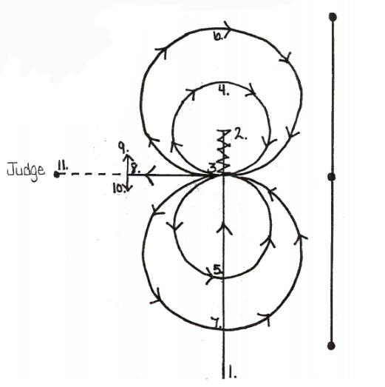

\\\
1. to 2. Run with speed past center marker.
2. Stop and back up to center of pattern.
3. Settle here for approximately 10 seconds. Start lope to the right. Figure eight should be inside end markers.
4. And 5. Ride small figure eight at moderate lope.
6. And 7. Ride larger figure eight at a faster lope, continue lope past point
8. Stop and settle horse for approximately 10 seconds.
9. Pivot right or left no more than 90 degrees.
10. Pivot opposite direction no more than 90 degrees.
11. Walk to judge and stop. Stay on Horse.
12. Judges will ask questions for horsemanship interview

